Module 05 Assignment 1 - Star Wars Scroll

Github Link : https://github.com/IsmaelB47/Star-Wars-Scroll
Snack URL : https://snack.expo.dev/@adil47/star-wars-scroll

Program Execution
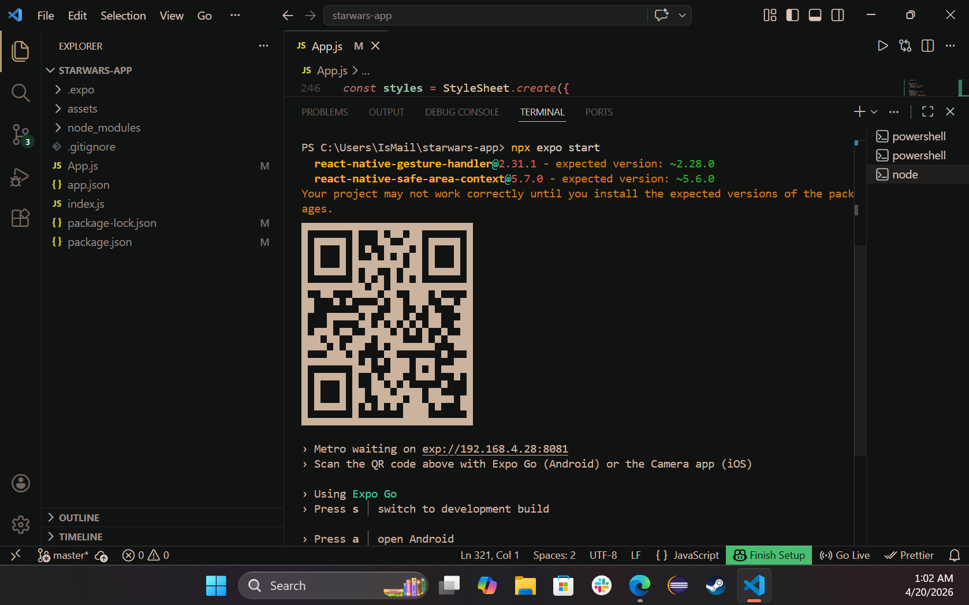

Results of Execution
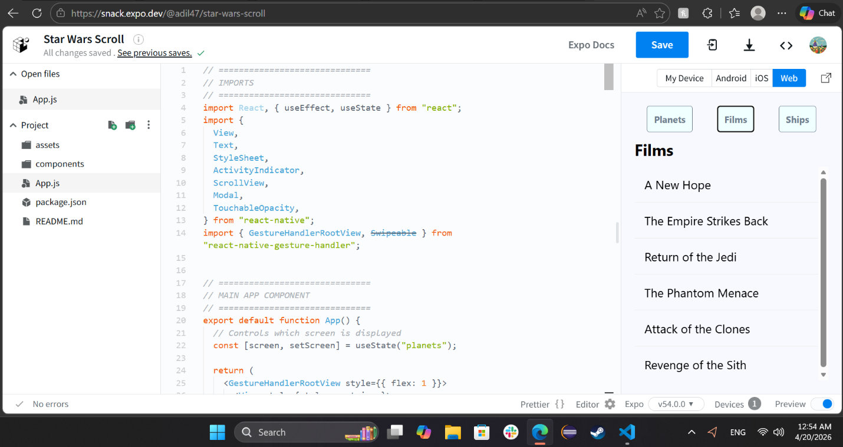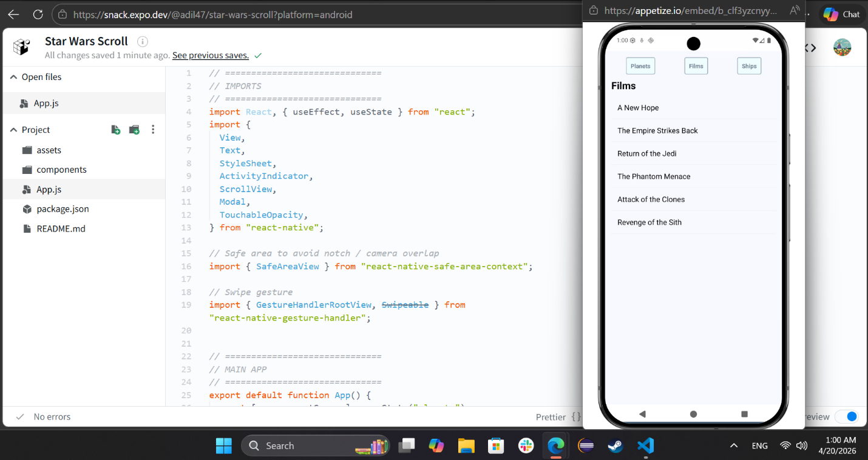

Coding Style
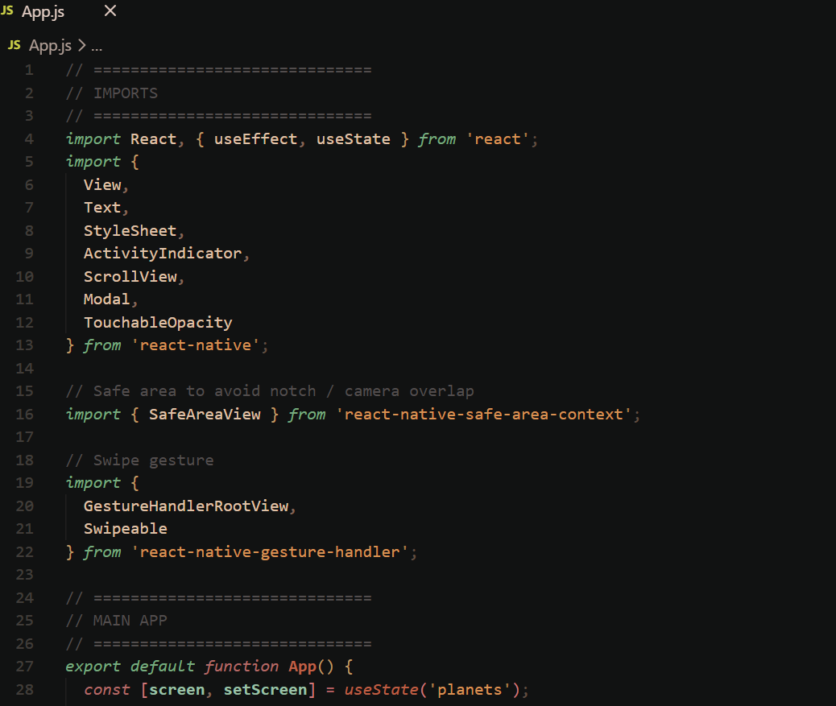
Code :
// ==============================
// IMPORTS
// ==============================
import React, { useEffect, useState } from 'react';
import {
View,
Text,
StyleSheet,
ActivityIndicator,
ScrollView,
Modal,
TouchableOpacity
} from 'react-native';

// Safe area to avoid notch / camera overlap
import { SafeAreaView } from 'react-native-safe-area-context';

// Swipe gesture
import {
GestureHandlerRootView,
Swipeable
} from 'react-native-gesture-handler';

// ==============================
// MAIN APP
// ==============================
export default function App() {
const [screen, setScreen] = useState('planets');

return (
<GestureHandlerRootView style={{ flex: 1 }}>
<SafeAreaView style={{ flex: 1 }}>
<View style={styles.container}>
{/* Navigation Buttons */}
<View style={styles.nav}>
<NavButton label="Planets" onPress={() => setScreen('planets')} />
<NavButton label="Films" onPress={() => setScreen('films')} />
<NavButton label="Ships" onPress={() => setScreen('ships')} />
</View>

{/* Render Screens */}
{screen === 'planets' && <Planets />}
{screen === 'films' && <Films />}
{screen === 'ships' && <Ships />}
</View>
</SafeAreaView>
</GestureHandlerRootView>
);
}

// ==============================
// NAV BUTTON
// ==============================
function NavButton({ label, onPress }) {
return (
<TouchableOpacity style={styles.button} onPress={onPress}>
<Text style={styles.buttonText}>{label}</Text>
</TouchableOpacity>
);
}

// ==============================
// MODAL (Chapter 23)
// ==============================
function ConfirmationModal({ visible, text, onClose }) {
return (
<Modal transparent visible={visible}>
<View style={styles.modalContainer}>
<View style={styles.modalInner}>
<Text style={styles.modalText}>{text}</Text>
<Text style={styles.modalButton} onPress={onClose}>
Close
</Text>
</View>
</View>
</Modal>
);
}

// ==============================
// PLANETS
// ==============================
function Planets() {
const [data, setData] = useState([]);
const [loading, setLoading] = useState(true);
const [selected, setSelected] = useState('');
const [visible, setVisible] = useState(false);

useEffect(() => {
fetch('https://www.swapi.tech/api/planets')
.then(res => res.json())
.then(json => setData(json.results || []))
.finally(() => setLoading(false));
}, []);

if (loading) return <Loader text="Loading planets..." />;

return (
<>
<Title text="Planets" />

<ConfirmationModal
visible={visible}
text={selected}
onClose={() => setVisible(false)}
/>

<ScrollView>
{data.map(item => (
<Swipeable
key={item.uid}
onSwipeableOpen={() => {
setSelected(item.name);
setVisible(true);
}}
>
<Item text={item.name} />
</Swipeable>
))}
</ScrollView>
</>
);
}

// ==============================
// FILMS
// ==============================
function Films() {
const [data, setData] = useState([]);
const [loading, setLoading] = useState(true);
const [selected, setSelected] = useState('');
const [visible, setVisible] = useState(false);

useEffect(() => {
fetch('https://www.swapi.tech/api/films')
.then(res => res.json())
.then(json => setData(json.result || json.results || []))
.finally(() => setLoading(false));
}, []);

if (loading) return <Loader text="Loading films..." />;

return (
<>
<Title text="Films" />

<ConfirmationModal
visible={visible}
text={selected}
onClose={() => setVisible(false)}
/>

<ScrollView>
{data.map((item, index) => {
const title = item.properties?.title || item.title;

return (
<Swipeable
key={index}
onSwipeableOpen={() => {
setSelected(title);
setVisible(true);
}}
>
<Item text={title} />
</Swipeable>
);
})}
</ScrollView>
</>
);
}

// ==============================
// SHIPS
// ==============================
function Ships() {
const [data, setData] = useState([]);
const [loading, setLoading] = useState(true);
const [selected, setSelected] = useState('');
const [visible, setVisible] = useState(false);

useEffect(() => {
fetch('https://www.swapi.tech/api/starships')
.then(res => res.json())
.then(json => setData(json.results || []))
.finally(() => setLoading(false));
}, []);

if (loading) return <Loader text="Loading ships..." />;

return (
<>
<Title text="Ships" />

<ConfirmationModal
visible={visible}
text={selected}
onClose={() => setVisible(false)}
/>

<ScrollView>
{data.map(item => (
<Swipeable
key={item.uid}
onSwipeableOpen={() => {
setSelected(item.name);
setVisible(true);
}}
>
<Item text={item.name} />
</Swipeable>
))}
</ScrollView>
</>
);
}

// ==============================
// REUSABLE COMPONENTS
// ==============================
function Loader({ text }) {
return (
<View style={styles.center}>
<ActivityIndicator size="large" />
<Text>{text}</Text>
</View>
);
}

function Title({ text }) {
return <Text style={styles.title}>{text}</Text>;
}

function Item({ text }) {
return (
<View style={styles.item}>
<Text style={styles.itemText}>{text}</Text>
</View>
);
}

// ==============================
// STYLES
// ==============================
const styles = StyleSheet.create({
container: {
flex: 1,
padding: 15,
backgroundColor: 'ghostwhite'
},

nav: {
flexDirection: 'row',
justifyContent: 'space-around',
marginBottom: 10
},

button: {
padding: 10,
backgroundColor: 'azure',
borderWidth: 1,
borderRadius: 4,
borderColor: 'slategrey'
},

buttonText: {
color: 'slategrey',
fontWeight: 'bold'
},

center: {
flex: 1,
justifyContent: 'center',
alignItems: 'center'
},

title: {
fontSize: 24,
fontWeight: 'bold',
marginBottom: 10
},

item: {
padding: 15,
borderBottomWidth: 1,
borderBottomColor: '#eee'
},

itemText: {
fontSize: 18
},

modalContainer: {
flex: 1,
justifyContent: 'center',
alignItems: 'center'
},

modalInner: {
backgroundColor: 'azure',
padding: 20,
borderWidth: 1,
borderColor: 'lightsteelblue',
borderRadius: 2,
alignItems: 'center'
},

modalText: {
fontSize: 16,
margin: 5,
color: 'slategrey'
},

modalButton: {
fontWeight: 'bold',
margin: 5,
color: 'slategrey'
}
});

